Linux Assignment

Here are the screenshots of the assignment given:

1. Creating and Renaming Files/Directories
Create a directory named test_dir using mkdir.
Inside test_dir, create an empty file called example.txt.
Rename example.txt to renamed_example.txt using mv

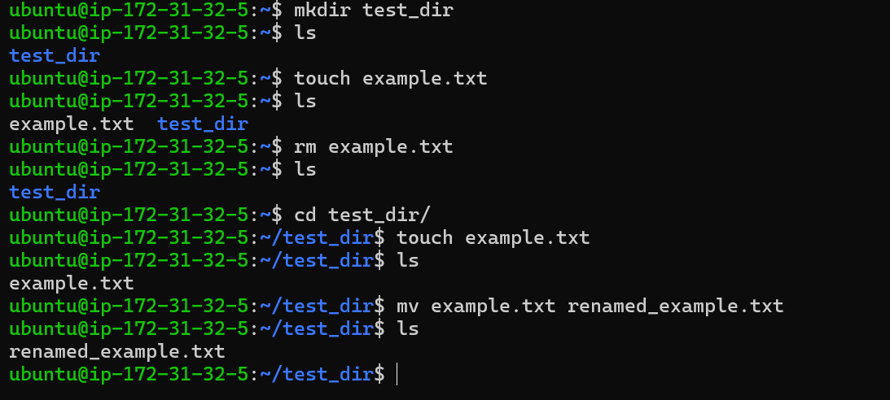
Creates a directory using mkdir , an empty file using touch command also renamed a file using mv command

2. Viewing File Contents
Use cat to display the contents of /etc/passwd.
Display only the first 5 lines of /etc/passwd using head.
Display only the last 5 lines of /etc/passwd using tail.
Ans: Used Cat command to view the content of /etc/passwd and used Head and Tail commands to view top and bottom 10 lines

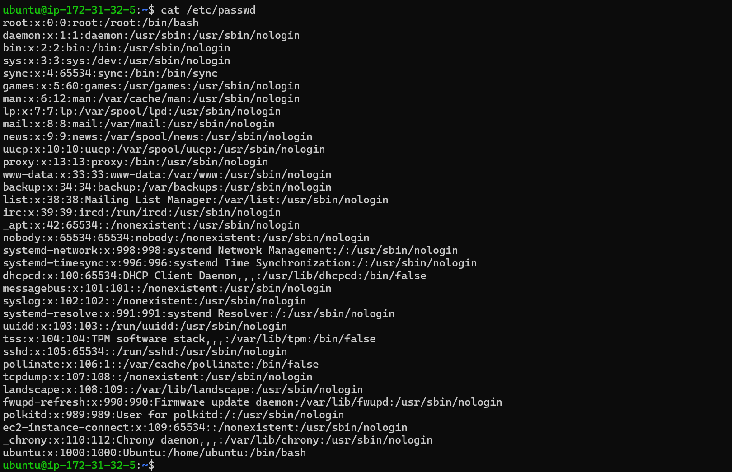
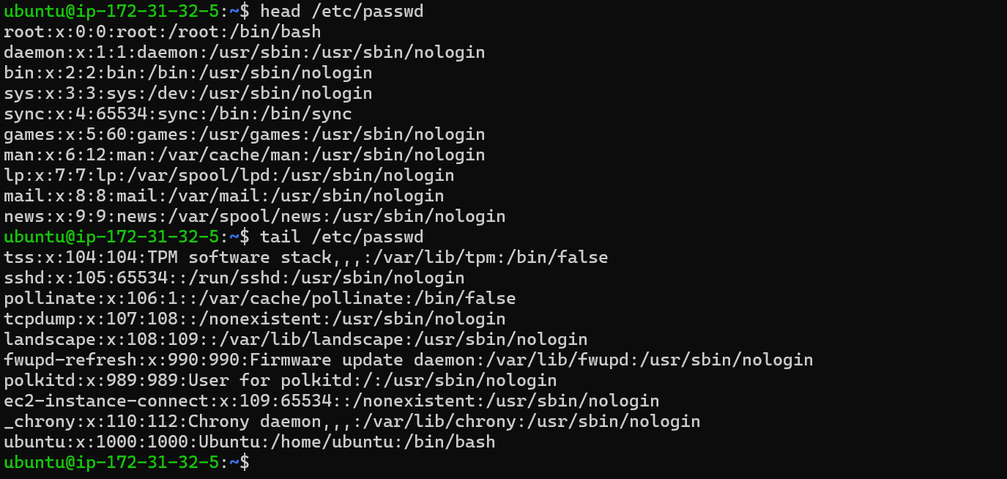

3.Searching for Patterns
Use grep to find all lines containing the word "root" in /etc/passwd.
4. Zipping and Unzipping
Compress the test_dir directory into a file named test_dir.zip using zip.
Unzip test_dir.zip into a new directory named unzipped_dir.

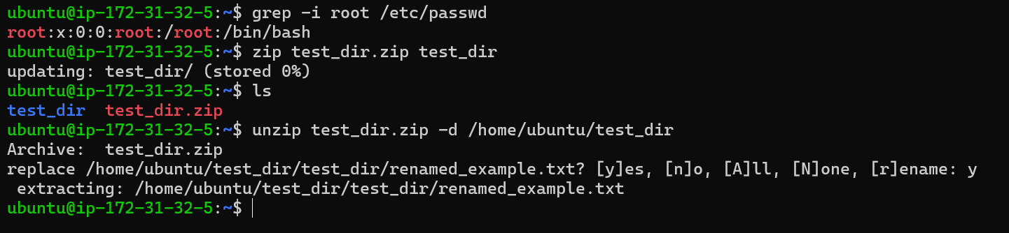

As mentioned in the screenshot used grep command to find root word in /etc/passwd.
-i is used to search root as in case sensitive.

5. Downloading Files
Use wget to download a file from a URL (e.g., https://example.com/sample.txt).

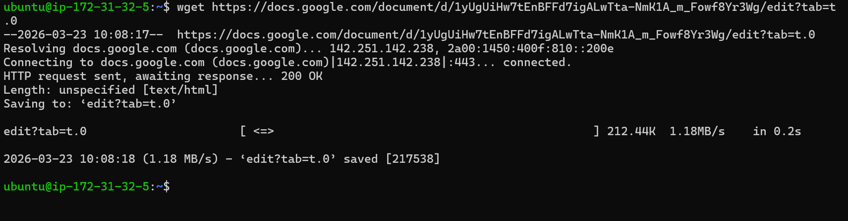
Used wget command to download the assignment file using https link in linux.

6. Changing Permissions
Create a file named secure.txt and change its permissions to read-only for everyone using chmod.
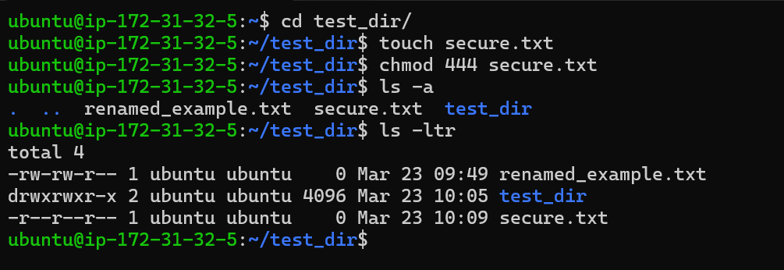
Changed the permissions of a file to read only for owner, group and others i.e, everyone has only read permission
7. Working with Environment Variables
Use export to set a new environment variable called MY_VAR with the value "Hello, Linux!".

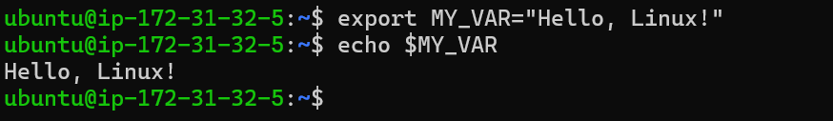

As mentioned used export command to define Hello, Linux! As MY_VAR.
Echoed $MY_VAR to confirm it. $ - helps to print the value/comment/string inside env variable.

